Finding the volume of a liquid:

Explain how you could find the volume of this liquid:

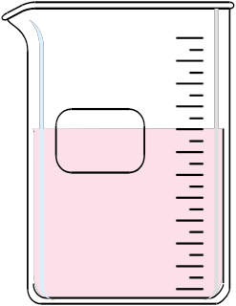

Finding the volume of an irregular solid:

Displacement is when you place the solid in a graduated cylinder or beaker of water, subtracting the water’s initial volume from the new combined volume to find the volume of an irregularly shaped solid.

Example: find the volume of the nut and bolt by displacement:
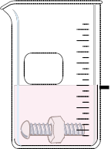
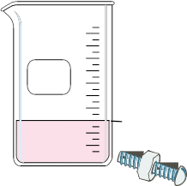

Volume of liquid: 15ml volume of liquid and nut/bolt: 25ml

