Science 7 Ecosystems Review

Vocabulary:

Be able to Match these to an explanation, or use them in your answers on the test.

Organism

Ecosystem
Population
Community
Biome
Biosphere

Abiotic
Biotic

Predator
Prey
Producer
Consumer
Carnivore
Omnivore
Herbivore
Scavenger
Decomposer

Photosynthesis
Chlorophyll
Respiration
Carbon Dioxide (CO2)
Oxygen (O2)
Water (H2O)
Carbon Cycle

Food Chain
Food Web
Ecological Pyramids
Bioaccumulation

Adaptations
Habitat
Niche

Succession (Primary and Secondary)
Pioneer species
Climax Community

Microbes

Sample questions from grade 7 students:

What is the difference between abiotic and biotic? Give an example of each in an ecosystem.

- Abiotic are non-living components (water, sunlight), and biotic are living things in an ecosystem ( bears, plants).

What is a predator, and what is prey?

- Predator is an animal that hunts on prey. (this needs more to be a complete answer)

Define producer and consumer (in your own words).

- A consumer doesn’t make their own food, and a producer can make their own food (through photosynthesis).

Define what an ecosystem means (in your own words) and give an example.

- Ecosystem means when different organisms have an interaction with each other. (more needed – think about abiotic too!)

Look at the picture below, and put a check beside three living (biotic) things and and x by three on-living (abiotic) things.

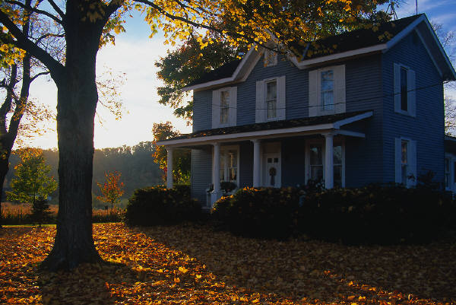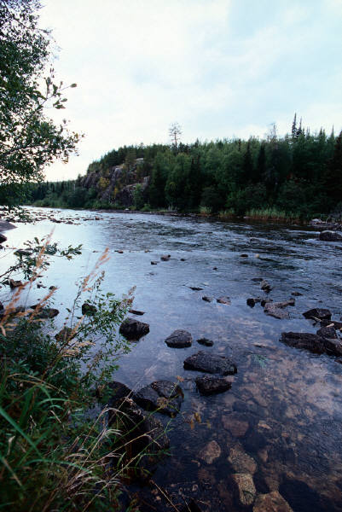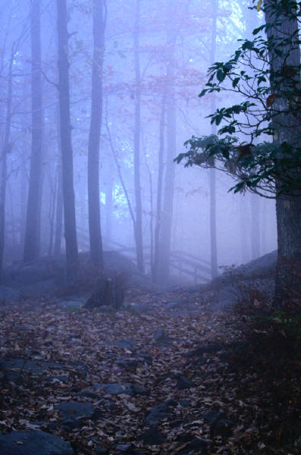

- Living Ex. Tree, bird, flower, squirrel, worms, mosquito, human, fish, minnow, frog, turtle, bacteria, etc.
Non-living Ex. Cloud, sun, rock, mud, clay, dead log, dead leaves, house, fog, rain, etc.

Name some features an ecosystem might have.

- (no answer provided)

Create a food web. Your web must contain at least one of the following:

Carnivore, herbivore, omnivore, producer, scavenger, decomposer

- Many various answers.

Draw / Create a food chain out of the following animals, and then label them as producers, and primary or secondary consumers:
Worms, Fox, Chicken, Corn

- Producer = corn, primary consumer = worm, secondary consumers = chicken (omnivore) and fox (carnivore)

What is the difference between herbivores, carnivores, and omnivores; and give an example for each?

- Carnivores eat only other animals (tiger, lion), omnivores eat both plants and animals (humans, dogs) , and herbivores eat only plants (rabbits, cows).

What is the chemical in plants leaves that helps them make food from the sun (and makes them look green)?

- Chlorophyll

Explain what a producer is and how they make / use their food (in detail).

- A producer is an organism that can make its own food. It makes its food through photosynthesis, and is able to use the food through respiration.

Photosynthesis is when the energy from the sun, CO2 and water are used by the plant to make sugar (energy) and O2.

Respiration is when the plant uses O2 and sugar and produces water and CO2.

What is a biome? Explain - draw a picture to help explain if you need.

- Biome is an area where there is similar plants, and related ecosystems living close together. Ex. Desert, Tundra, Grassland, etc.

Write a definition of population in your own words:

- Population is the number of the same species living in a specific area.

Other recommended questions from Mrs. Comte:

Why do we lose energy as we move up levels of an ecological pyramid?

What is bioacculumation? Explain using an example that may be found in nature.

Why are adaptations important for organisms? Give an example of an adaptation.

What is succession? How are primary and secondary succession similar and different?

What is the biosphere?

How are Photosynthesis and Respiration connected in the Carbon cycle? Draw and label a diagram to support your answer.

How do you find the total magnification of a specimen that you have looked at under the microscope?

How would the population of consumers be affected if a forest fire decreased the number of producers in an area? Explain.

