Parts of Cells Review Crossword
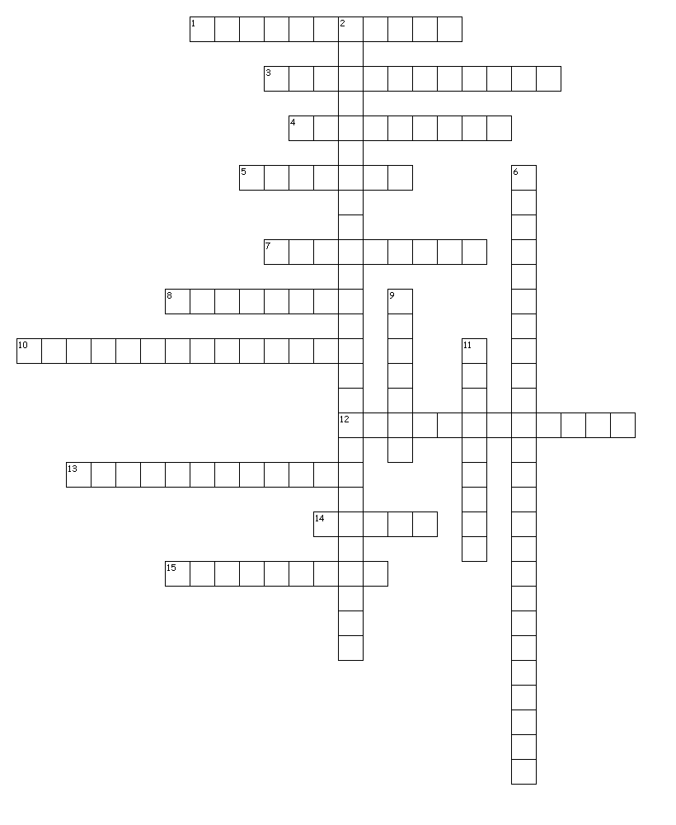
Across
1. Also known as DNA; construction plans for the cell.
3. Provide the cells with energy.
4. Watery fluid inside the cell that helps to transport materials and stores wastes.
5. “Brain” or control center for the cell.
7. Put together proteins using information from the nucleus and molecules from the cytoplasm.
8. Protects and supports the plant cell.
10. Storage for proteins in the cell inside vesicles.
12. Contain chlorophyll, which allows plants to make their own food from sunlight.
13. Controls the movement of materials into and out of the cell, like a gatekeeper.
14. Tiny hairs that work to help a cell move. Not found on all cells.
15. Tail that helps some cells to move. Not found on all cells.
Down
2. Folded membranes inside the cell that transport materials but do not have ribosomes attached.
6. Folded membranes inside the cell that transport materials and do have ribosomes attached.
9. Material storage in the cell. Plants have a much larger one than animal cells.
11. Patrol the cytoplasm to protect the cell from invaders, and break down old molecules to reuse them in the cell.

