Student Investigation: Mass , Volume & Density Name:

Purpose: to calculate the densities of several regularly and irregularly shaped solids and liquids.

Part A: Regularly Shaped Solids (Rect. Prism, Triangular Prism, Cube, Cylinder)
Example:

- Calculate the volume using math formulas. (check your notes!)
Volume of rectangular prism= Area of base x height
= length x width x height
3 cm x 2 cm x 2 cm = 12 cm3

- Find the mass using a balance scale
mass = 24 g

- Calculate the density using the formula d = m/v.

density = mass = 24 g = 2 g/cm³
volume 12 cm³

Activity: Choose a regularly shaped solid from the tray, and calculate its volume to the nearest tenth of a cubed cm.

- Choose an object.
My regularly shaped solid object is: ____________________________________

- Find the formula for volume of that object.
The formula to calculate the volume of this object is Area of Base x Height, which really means _______________________________________________________________________.
(look in your math notes if you do not remember!)

- Calculate the volume to one decimal place. Do not forget units!
Here is my work to calculate the volume:

- The formula to calculate density is MASS divided by VOLUME.
Calculate the density of the object to one decimal place. Do not forget units!
Here is my work to calculate the density:

Part B: Irregularly Shaped Solids

Example from class:
- Measure volume of object using displacement
Volume of liquid: 15ml
volume of liquid and nut/bolt: 25ml
Nut and bolt volume = 25 mL – 15 mL = 10 mL (found using displacement)

- Then use a balance scale to find the mass.
mass of nut and bolt= 20 g (found using a scale)

- Calculate density using the formula d = m/v.
density = mass / volume = 20g / 10 ml = 2 g/mL

Activity: Choose an irregularly shaped solid object to calculate its density.

Step 1: Choose a small irregularly shaped object that you can get wet! (Coin, marble, stone, nail, paperclips, eraser, etc).

My irregularly shaped object is : ____________________________

Step 2: Use displacement to find the volume of that irregularly shaped solid object. Include units!

Volume of liquid: ___________________________________
Volume of liquid and object: ______________________________________
Object volume: ______________________________

Step 3: Find the mass of the object using a balance scale. Include units!

Mass of object: ______________________

Step 4: Calculate the density of the object to the nearest tenth using the formula d = m / v.

Show your work to calculate density below. Don’t forget units!

Part C: Density of Liquids
To calculate the density of a liquid:
Example:
- Use a balance scale to find the mass of a beaker / container
Mass of empty container = 15 g

- Pour 100 mL of a liquid into the beaker and find the combined mass of the beaker and the liquid
Mass of container with 100 mL of liquid = 25 g

- Determine the mass of the liquid by subtracting the mass of the container from the total mass of the liquid and container.
Mass of 100 ml of liquid = 25 g – 15 g = 10 g

- Calculate the density of the liquid using the formula d = m/v
density = mass of liquid ÷ volume of liquid
= 10 g ÷ 100 ml
= 0.1 g/ml

Activity: Finding the density of a liquid (like water).

- Use the balance scale to find the mass of the empty beaker or container you will be using. Remember to include units!

Mass of empty container: _________________________________

- Measure out 100ml of water and pour it into the container. Use the balance scale to find the mass of the container with the water inside. Units!

Mass of water and container together: ___________________________________

- Find the mass of only the water by subtraction. Remember units!

Mass of just the water: _________________ - ___________________

=_______________________

- Calculate the density of the water to the nearest tenth using the formula d = m/v. Do not forget units!

Particle Theory and Density
- Solids, liquids and gasses have different densities because of the amount of space their particles take up.
- In general, solids are the most dense (more particles in less space), and gasses are the least dense (less particles in more space).
- Water is an exception to the rule that solids are denser than the liquid state of the same type of matter. Water is the most dense at 4 degrees Celcius, and becomes less dense when it freezes. This allows ice to float on lakes in winter and organisms to live below.
Particles in gold bar:

____________________________
Particles in melted gold:
Show what you know:
1. Draw the particles in the diagram below.

gold bar

melted gold

a. What two states of matter are seen in the above diagram?

b. What type of energy was added to cause the change of state to occur?

c. Which is less dense, the gold bar or the melted gold? Why?

2. Draw the particles in Balloon B and describe the density of the air in Balloon B in comparison
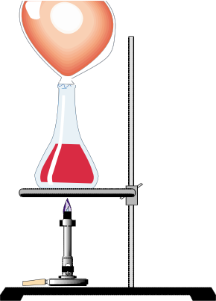
to Balloon A.
Particles in balloon A:

____________________________
Particles in balloon B:

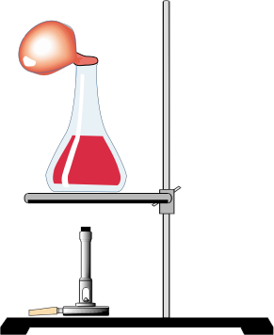

Balloon A Balloon B

- Which balloon contains air that is more dense? Explain.

- Describe a way you could test to see which balloon actually is more dense.

Activity: Comparing Objects & Densities

- Select two objects that have the same volume but a different mass. Find and record the volume and the mass for each, and then calculate the densities for each.

Describe each object! | Volume (cm3) | Mass (grams) | Density (Mass ÷Volume)
Object 1:
Object 2:

- Using the particle theory of matter, explain why these objects that have the same volume can have different masses. Use a diagram in the explanation.

- What pattern do you notice between volume, mass and density?

- Select two objects that have the same mass but different volumes. Find and record the volume and the mass for each object, and then calculate the densities for each.

Describe each object! | Volume (cm3) | Mass (grams) | Density (Mass ÷Volume)
Object 1:
Object 2:

- What are the units for density? Explain why. (Make sure you have the units in your chart.)

- What pattern do you notice?

DEMO: Density Towers to Compare Densities

As a class, construct a density tower composed of various liquids and solids. The substances with the greatest density will be on the bottom, the substance with the least density will be on the top, with the range of densities in between.

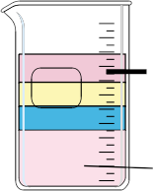
least dense

most dense

Density Calculations:
Calculate the densities and solve the following problems. Show your work, and remember units!.

- A gas has a mass of .05 g and fills a 100 mL container. What is its density?

- Object B is a solid that has a mass of 20 g and a volume of 10 cm3. What is its density?

- Object C is a solid that has a volume of 15 cm3 and a mass of 6 g. What is its density?

- If objects B and C were placed in pure water, which has a density of 1.0 g/mL, what would happen? Why?

- Objects D and E have the same volume. Object D has a greater mass. Identify which has a greater density and explain your reasoning.

