Lab: Fluid Compressibility Comparison Name:

Compressibility is the ability of fluids to be squeezed into a smaller volume.
- Gases are compressible because their particles are far apart.
- Liquids are considered almost incompressible because their particles are much closer together and there is no visible change in volume when they are being compressed.

Part A: Comparing Compressibility

Use a syringe to compare the compressibility of several different fluids, including air, following these steps:
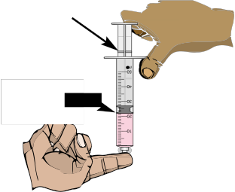
plunger

stopper

• Draw back the plunger and fill the syringe with specific fluid.
• Plug the hole and push in the plunger.
• Observe what happens. The change in volume represents the level of compressibility.
• Record your data in the table below and indicate whether the fluid is compressible or incompressible.

Fluid | Initial Volume (filled) | Final Volume  (when pushed) | Change in Volume | Compressible or Incompressible?

Part B: Observing Decompression

Some systems use the rebound of compressed fluids to move parts.

- Compress various fluids (used in Part A) as much as possible
- Release the plunger and observe the distance the stopper rebounds.
- Use the table below to record which fluid rebounded more after decompression.

Fluid | Initial Volume (filled) | Compressed Volume (when pushed) | Distance rebounded (when plunger released)

Results:

- In general, did you find that liquids or gasses were more compressible?
Explain why this is, based on what you know about the particles in liquids and gasses.

- In general, did you find that liquids or gasses rebounded more after decompression? Explain why this might occur?

- Find / explain one place in real life where you might use see compression or rebounding after decompression used. Use the computers / textbook if you need.

Pneumatic Versus Hydraulic Systems

Purpose:
Working in groups, set up and conduct the following experiments to compare how a pneumatic system, as compared to a hydraulic system, transmits force.

- Ensure that you work over a sink or plastic tub when filling the syringes with water.

- Glycerine (petroleum jelly) may have to be added around the rubber stopper to ensure a complete seal and allow the plunger to move back and forth smoothly and easily.

Part A: Pneumatic System
Materials:

Process:
- Push in the plunger completely on syringe A and then attach syringe A with rubber tubing to syringe B, whose stopper is at the last measurement indicator (filled with air).
- Push in the plunger on syringe B.
- Record the distance the plunger on syringe B is moved and the distance syringe A’s plunger moves.

Part B: Hydraulic System
Materials:

Process:
- Attach rubber tubing to syringe B and then, by pulling on the stopper of syringe B, fill the syringe and the tubing with water.
- Push in the plunger completely on syringe A and then attach it to the rubber tubing that is connected to syringe B, which is filled with water.
- Push in the plunger on syringe B.
- Record the distance the plunger on syringe B is moved and the distance syringe A’s plunger moves.

syringe A syringe B

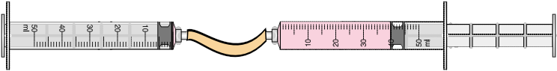

Answer the following questions:

1. A system that transfers force efficiently would have the resulting movement of the load be equal or near equal to the distance the effort force travelled.

An example of an efficient transfer of force would occur if the plunger on Syringe A (providing the effort force) travelled five centimetres and the plunger on syringe B (load) travelled an equal distance (5 cm).

Based on this information, which fluid in your experiment transferred force more efficiently? Explain how you know.
______________________________________________________________________________________________________________________________________

2. A hydraulic system uses liquids for the transmission of force and a pneumatic system uses air for the same purpose.

Based on the results you observed in your experiment involving pneumatic and hydraulic systems, which system would be more efficient to use if you were lifting a large load but did not have much force in the form of person power to lift the
load? Why? _________________________________________________________________________________________________________________________________________________________________________________________________________

3. What is the relationship between a fluid’s compressibility and its ability to transmit force?
Ex: The _____ compressible the fluid, the ______ it is at transmitting force.
(more / less) (better / worse) ______________________________________________________________________________________________________________________________________

