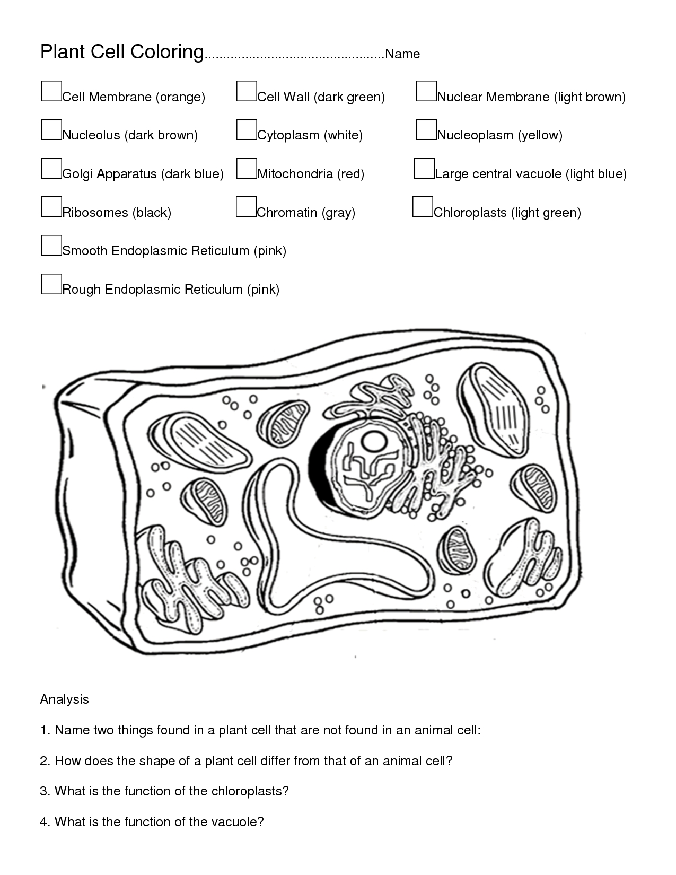
Name:____________________________________________

Animal Cell Coloring
Cell Membrane (light brown) | Nucleus (black) | Mitochondria (orange)
Cytoplasm (white) | Golgi Apparatus (pink) | Lysosome (purple)
 | Cilia (yellow)
 | Rough Endoplasmic Reticulum (dark blue) | Chromosomes (dark green)
Ribosome (red) | Smooth Endoplasmic Reticulum( light blue)
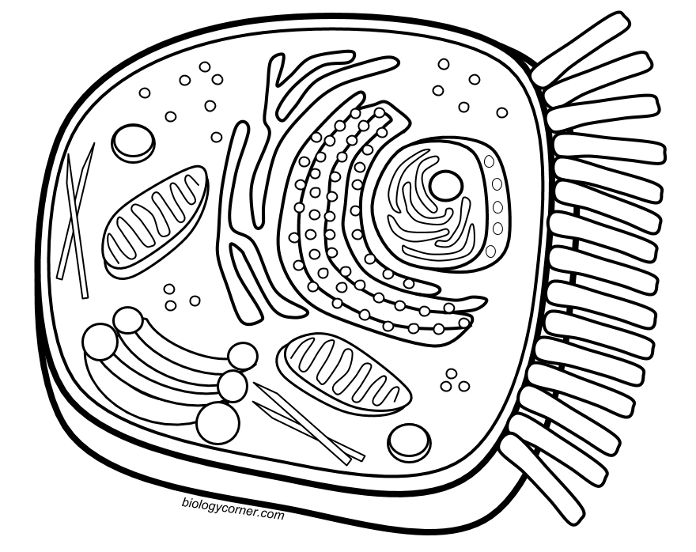
Briefly describe the function of the cell parts.
1. Cell membrane _____________________________________________________
2. Endoplasmic Reticulum _______________________________________________
3. Ribosome _________________________________________________________
4. Golgi Apparatus ____________________________________________________
5. Lysosome _________________________________________________________
7. Mitochondria ______________________________________________________
8. Nucleus ___________________________________________________________

