Mass vs. Weight Activity
____________ is the amount of matter in an object. It is measured in grams (g) and remains the same no matter where the object is.
____________ is a measure of the FORCE acting on an object. It is measured in NEWTONS (N)
Object Name | Mass (balance scale) | Weight (spring scale)
_________ is the biggest force affecting weight. This means that weight can change depending on gravity.
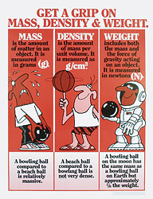

On Earth, how do we calculate the weight of an object?

Loads & Forces
Loads
- are external forces acting on a structure.
- There are two types of loads:

- (aka LIVE loads) -
Examples:

- (aka DEAD loads) -
Examples:

Forces
- Any push or pull on a structure.
- There are 2 types
- External-

- Internal-
Can be further divided into 4 categories:
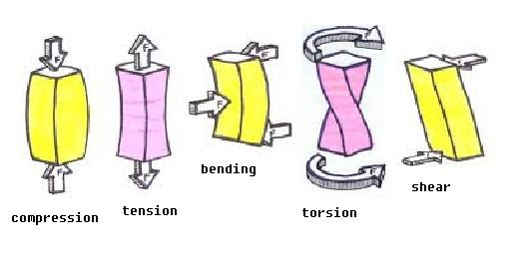
- Compression
- Tension
- Torsion
- Shear

** Make flow chart or graphic organizer on the back of this page to help you remember these key ideas and the connections between them!**

