Maps of Ancient Egypt
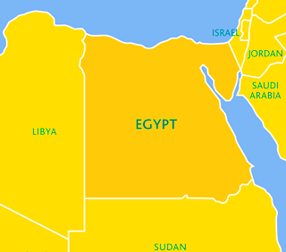
∇On the unlabelled map below, use the textbook, atlas or the internet to find and label the following countries and bodies of water that surround Egypt:

- Israel
- Libya
- Saudi Arabia
- Jordan
- Sudan
- Mediterranean Sea
- Red Sea

∇Explore the Interactive map at the following website: http://www.childrensuniversity.manchester.ac.uk/learning-activities/history/ancient-egypt/explore-ancient-egypt/

∇Label the following places on the blank map, writing a few important points beside each as you click on them on the interactive map:
- Rosetta-

- Alexandria-

- Nile Delta-

- Heliopolis-

- Giza-

- Cairo-

- Saqqara / Sakkara-

- Memphis-

- The Nile River-

- Mediterranean Sea-

- Red Sea-

- Luxor-

- Thebes-

- Valley of the Kings-

- Valley of the Queens-

- Aswan-
∇Take the Quiz:
- What is the Nile Delta? (and why was it important: _______________________________________ )
  - An Egyptian aeroplane
  - A letter in the Egyptian alphabet
  - Land where the Nile joins the Mediterranean Sea

- Which Pharaoh died at Alexandria?
  - Hatshepsut
  - Cleopatra
  - Ramsses

- Who is Memphis, the capitol of the Old Kingdom, named after? (and why was he important: ______________________________________________________________ )

  - Menes
  - Ramesses
  - Elvis

- Where did Howard Carter find Tutankhamun’s tomb? (and in what year: ________)
  - Giza
  - The Valley of the Kings
  - The Valley of the Queens

- Where was the Egyptian capital city during the Middle and New Kingdoms?
  - Thebes
  - Cairo
  - Memphis

Assessment: Research and Communication: / 20 marks
- Text, atlas and/or websites used effectively to find / label maps with all 26 places listed /10
- Notes made on important info from cities /towns, and quiz answered correctly. /10

