Heat and Temperature Design Project
– based on info on P. 122-123
Https://www.sciencebuddies.org/science-fair-projects/engineering-design-process/engineering-design-process-steps#theengineeringdesignprocess

The Engineering Design Process
Engineers and designers use the engineering design process, shown in the diagram and table, to solve a problem by creating new products, systems, or environments.
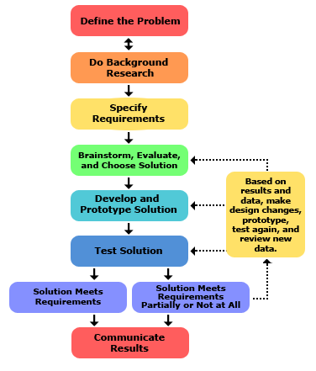
The process rarely moves in a linear fashion. Instead, designers jump back and forth between the steps as they move toward the final solution.

Steps in Design Process: (fill this out as you go) Name:
Define the Problem. The engineering design process starts when you ask the following questions about problems that you observe:
- What is the problem or need?
- Who has the problem or need?
- Why is it important to solve?
Your choices (Circle one) – Keep it Cool Or Heat it up – Solar heater / cooker
(Write about the problem here)

Do Background Research: Learn from the experiences of others — this can help you find out about existing solutions to similar problems, and avoid mistakes that were made in the past. So, for an engineering design project, do background research in two major areas:
- Users or customers
- Existing solutions
Make sure to write down websites that you used for your research! These need to be included in a bibliography. (Write them down here!)
Sources:

Specify Requirements / Criteria: Design requirements state the important characteristics that your solution must meet to succeed. One of the best ways to identify the design requirements for your solution is to analyze the concrete example of a similar, existing product, noting each of its key features.
(In class, we discussed the 3 criteria for each of the options of project. Write those 3 down, and any others you would like to include – a time frame and / or temperature standard should be decided for each group before testing begins!!)
Criteria:

Brainstorm Solutions: There are always many good possibilities for solving design problems. If you focus on just one before looking at the alternatives, it is almost certain that you are overlooking a better solution. Good designers try to generate as many possible solutions as they can. (Write down as many as you can think of)
Ideas:

Choose the Best Solution: Look at whether each possible solution meets your design requirements. Some solutions probably meet more requirements than others. Reject solutions that do not meet the requirements.
(Explain your choice here: )

List the materials you will need for your solution, and make a plan to have them at school for the next Science class.
Materials:

Build a Prototype / model : A prototype is an operating version of a solution. Often it is made with different materials than the final version, and generally it is not as polished. Prototypes are a key step in the development of a final solution, allowing the designer to test how the solution will work.
Draw plans for the steps in building your device, and take pictures as you go.

Test and Redesign: The design process involves multiple iterations and redesigns of your final solution. You will likely test your solution, find new problems, make changes, and test new solutions before settling on a final design. Think about the controls you will have to ensure your test is fair.
Explain your test, including controls:

Explain problems you encountered during testing, and changes made to fix them:

Communicate Results: To complete your project, communicate your results to others in a final report and/or a display board (poster, photostory, brochure, powerpoint, etc.). Professional engineers always do the same, thoroughly documenting their solutions so that they can be manufactured and supported.

