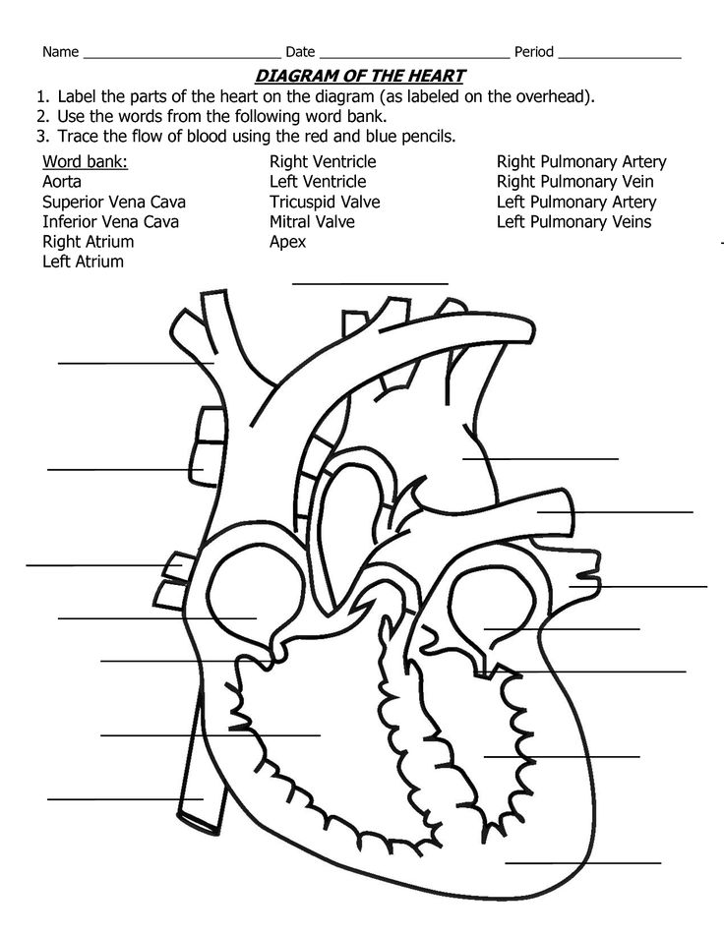
The heart muscle tissue is called _______ muscle, which is made of ______ cells.
Vessels are lined with ___________ tissue and cells.
Part of the heart is made of _______ cells, which make adipose tissue.
Extra Challenge - Path of the Blood (through the body):
Start at the big toe, and see if you can list the structures the blood cell carrying carbon dioxide will pass through on its trip around the body, and back to the big toe to bring it oxygen.
(Hint: You will have to use most of the heart diagram labels, and also add in lungs, arteries of the body, capillaries of the body (and big toe) and veins of the body.

Respiratory System Diagram
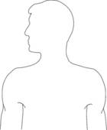

The diaphragm is muscle tissue made of _________ muscle cells.
____________ tissue lines this system. There are 3 main kinds of epithelial cells in the respiratory system: _________cells, __________ cells , and _________ cells.
Presentation Handout By Mrs. Comte
Cells and Tissues:
Muscle cells – muscle cells are arranged in rows, and work together to contract or relax to make movement. The heart is made of cardiac muscle tissue, the blood vessels are made of smooth muscle tissue, and the diaphragm is made of skeletal muscle tissue!
Nerve cells - Connect to make nerves (a.k.a neurons) that send messages from the brain to the cells and back again. Nerves (like the Vagas nerve) can send messages to control breathing rate or heart rate.
Fat cells - Fat cells make fat tissue (also called adipose cells / tissue). Fat tissue controls temperature (insulation), stores energy, and also protects the organs including the heart, lungs, and blood vessels from injury. Organs of the Circulatory System:
Blood cells - Main types of cells are red (RBC), white (WBC), and platelets. They all do different jobs in the blood to help us survive, and together make blood tissue.
Epithelial cells - Three main types found in the respiratory system: ciliated cells (have cilia), basal cells (repair), and goblet cells (make mucus). These make up epithelial tissues.
Endothelial cells - these are another type of epithelial cells that make up the inside layer of blood vessels. These have really thin walls to help with gas exchange (like in alveoli).
Match the cells/tissue with the job it does!
Smooth muscle These cells carry oxygen and carbon dioxide, as well as nutrients, to all cells of the body.
Cardiac muscle This type of cell and tissue helps with insulation and protection from injury. It is also a storage place for excess nutrients.
Skeletal Muscle This type of muscle makes up the blood vessels.
Fat This type of cell and tissue is only found in the heart.
Nerve This type of cells and tissue makes the diaphragm
Platelets This type of blood cell helps with forming clots to stop blood from leaking out of broken vessels.
Red blood cells These cells are part of the body’s defense against disease because they eat invaders, and they create antibodies that help fight future infection.
White blood cells These cells line the inside of systems, and can help make mucus, repair, move substances along, or help with gas exchange.
Epithelial cells This type of cell and tissue sends messages like electrical current to the heart and lungs to keep them working without us having to think about it.
Organs & Systems Diagrams
Organs of the Circulatory System:
- Heart, Lungs, Blood vessels (arteries, veins, and capillaries)
- Diagram of heart
- Path of the blood challenge
Organs of the Respiratory System:
- Mouth and nose, larynx, pharynx, trachea, bronchi (bronchus), lungs (bronchioles, alveoli), and diaphragm
  - Diagram of Respiratory System

Vocabulary words:

Deoxygenated blood – blood that is carrying Carbon dioxide, and has low levels of oxygen. Purplish coloured.

Oxygenated blood – blood that is carrying oxygen on the red blood cells, attached to the hemoglobin. It is bright red in colour.

Valve – a flap in the veins, or between chambers of the heart, that only open in one direction, so that blood can only flow in one direction

Artery – vessel that carries blood away from the heart – only two carry deoxygenated blood!

Vein – vessel that carries blood back to the heart – only two carries oxygenated blood!

Capillary – blood vessels that are so small they are one cell thick. This is where gas and nutrient exchange happens.

Alveoli – Tiny air-filled sacs that form the end of the respiratory “tree” in the lungs. They are covered in nets of capillaries so that gas exchange can occur.

Gas Exchange – when oxygen and carbon dioxide switch places on red blood cells through diffusion.

Inspiration (inhalation) – bringing air into the lungs, the diaphragm contracts (flattens), the space inside lungs increases

Exhalation – pushing air out of lungs, the diaphragm relaxes, letting the space inside shrink.
Diseases of the circulatory system: Select one to describe with point form notes
Heart attack
Anemia
Heart murmur

Diseases of the respiratory system: Select one to describe with point form notes
Pulmonary embolism
Asthma
Pneumonia

Connections to other body systems:
All systems are connected to these two systems because every cell of the body needs the _________________ and nutrients that are delivered by the blood so they can perform cellular respiration in their ___________________to make usable energy. In addition, all cells need to remove the left-over carbon dioxide that is produced via the blood to the lungs.
Some other systems that have additional connections are:
- Digestive system – nutrients from food are picked up in the stomach and intestines, and delivered to all cells of the body by the blood.
- Muscular system – the heart is a muscle, and the diaphragm is too
- Skeletal system – the blood cells are made in the bone marrow
- Excretory system – the blood is filtered to remove wastes (other than carbon dioxide) by the organs of this system (kidneys, liver, etc.)
- Endocrine system – the hormones travel through the blood to reach their destinations to deliver messages to make changes to the body. Hormones can affect the heart rate and breathing rate too!
- Nervous system - brain stem and nerves control the heart and breathing rates.
- Integumentary system – blood repairs cuts and bruises on the skin, and help defend this first layer of the system
- Immune system – white blood cells are a major component of the body’s defense system
- Reproductive system – mother’s blood provided by the umbilical cord to the developing fetus contains oxygen and nutrients, and returning blood removes wastes. Milk is also produced by the blood

