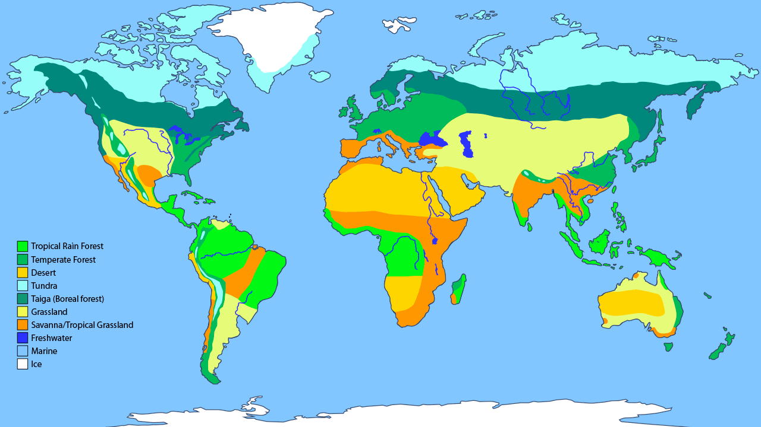

http://askabiologist.asu.edu/sites/default/files/resources/articles/biomes/world-biomes-map.gif

